Halloween Newsletter 2023  Crinkill N.S.  Contact number: (057) 9120803  Facebook: https://www.facebook.com/CrinkillNS  Instagram: https://www.instagram.com/crinkillns  Twitter: https://twitter.com/CrinkillNS  Dear Parents,  We have had a great term here at Crinkill N.S. full of fun activities and lots of learning! We welcomed our new Junior Infants. We also welcomed our new students that have entered other classes throughout the school. All children have settled in very well.  We are currently in the process of building a new website. We will inform you when it is published. You can continue to follow us on our Twitter, Facebook and Instagram pages for weekly updates on all our fun activities.  We have a new teacher this year. We would like to welcome Ms. Shiels to Crinkill NS. We would also like to welcome back Ms Quaid from her career break. We would like to send best wishes to Ms. Haines as she begins her teaching career in County Kerry.  We will shortly be enrolling new Junior Infants for September 2024 so please contact the office for the enrolment form after Halloween.  We hope all our children and parents have a great Mid-Term and we look forward to seeing you all again on Monday, the 6th November!  Mrs. Nolan  Cross Country Championships  32 children from Crinkill NS competed in the cross-country championship on the 5th of October last in Tullamore Harriers. The races were long distance cross-country races and we are very proud of all the children involved. Well done also to our medalists on the day. |  | 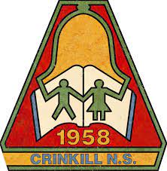  Upcoming Events  Enrolment for Sept 2023  Enrolment for new Junior Infants will open on the Monday, the 6th November. Please contact the office for enrolment forms. Enrolment will close on the 26th January 2024.  Board of Management Elections  We are currently in the process of electing a new BOM. The new Board will take over on the 1st December.  Tag Rugby  Tag rugby with Wren continues until Christmas. No charge to parents.  Hurling  Hurling with Ryan continues next term and throughout the year. No charge to parents.  Music with Ms. Killeen  2nd to 6th class are continuing music lessons with Ms. Killeen. 5th and 6th class will be learning keyboard after Halloween. Thanks to the Parents Association for purchasing the keyboards for the students.  Halloween Fancy Dress  We are looking forward to Friday and seeing the children in all their costumes. Please remember to bring in a €2 donation on the day. Have a look at our social media accounts for pictures and videos.  Playground Equipment  The school has purchased a set of swings and monkey bars. We are also in the process of developing a long jump area.
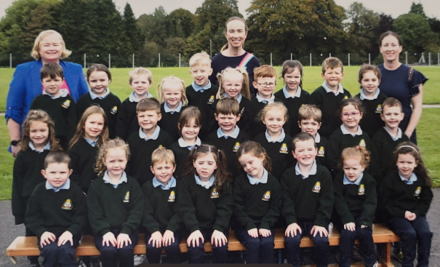  Our New Junior Infants  Here are our new Junior Infants. Their teachers are very proud of their hard work and how well they have settled in.  Our New Preschoolers  Our preschoolers are also settling in well. They are enjoying lots of fun hands-on activities using playdough, messy play, art & crafts and outdoor fun!  3rd class:  All month 3rd class have been very busy with Ms. Connolly learning all about the Stone Age. They made Stone Age weapons and jewellery from clay. They also did a project on the Stone Age in pairs and presented them to their classes.  Birr GAA County Final Competition  A big congratulations to our students for taking part in the Birr GAA County Final Competition. Rowan Hayden (junior infants), Finn Cummins (1st class) and Antoni Sosowski (5th class) were winners for class competitions. Each winner will receive a new Offaly Jersey!  Cumann na mBunscol Football Finals  Best of luck to our boys and girls who are playing their Cumann na mBunscol football finals. Hopefully the finals will be held this week. The boys will be playing the Boys School and the Gaelscoil combined. The girls will be playing Cloghan. Well done so far to all our boys and girls. They have been training very hard and thank you to the teachers who have helped with organising matches and training.  Fast Feet Competition:  On the 23rd November next 30 children from 2nd, 3rd and 4th class will be competing in the Fast Feet Challenge in Drumcullen, This is a short distance race challenge. Children will be able to try out for this competition after midterm.  Parking  Our neighbours have asked to be mindful when dropping off and collecting children from school and please do not part at people’s gateways.  Shoe Box Appeal  A leaflet on the Shoe Box Appeal was sent home yesterday. If you wish to partake in his appeal please send the shoebox back to school by Monday, the 6th November 2023.  Check out our Facebook and Twitter pages for all news |  | 1st class:  1st class started learning the tin whistle. They can already play Mary had a Little Lamb. Well done 1st class.  Senior Infants:  Ms. Treacy and senior infants have been very busy learning all about hedgehogs this month.  4th class:  4th class are taking part in a Junior Engineers Project this year.  6th class:  6th class completed group projects on local history. They studied Crinkill Barracks and its historical importance.  Ukrainian Movie:  Ms. Richards and the Ukrainin students went to Birr Theatre to watch a Ukrainian movie, Mavka The Forest Song. They had a wonderful time watching a movie in their native language, thank you Ms. Richards!  5th class have been very busy working on the Blue Star Programme. Each student has worked on a project on an EU country and presented their findings to the class. They will be continuing their work throughout the year with a range of activities to explore the workings of the European Parliament and Irelands participation in the EU.  ISPCC Workshop  2nd class took part in a workshop by children’s author Katie O’Donoghue in partnership with ISPCC Childline. The children enjoyed participating in the creative well-being activities while listening to the storytelling.

