School Contact Details

phone: 057 9120803
email: office@crinkillns.ie
Office hours – 9.30am – 3pm

School timetable
The school timetable is as follows:

School commences 9.20 am
Morning Break 11.00am – 11.20am
Afternoon Break 1.00 pm – 1.20 pm

Infant classes are dismissed at 2.00 pm. Infants must be collected at 2p.m.
1st – 6th Classes are dismissed at 3p.m.

Points to note:

Assembly
All classes assemble in the hall each morning for 9.20am (gates open at 9:10) – Junior infants enter the school through the small gate at the side of the school near the teacher’s car park. Adults remain at the gate.

Absences
When a child is absent an explanation in writing is required. Please send an email to school office stating the reason for absence. The school must keep these on file for inspection by Tusla. If a child has to leave early, a note should be given to class teacher and child must sign out in the office. If a child is absent for 20 days or more the school has a legal obligation to notify Tusla. Children should not be taken out of school for holidays during the term.

Accidents
Every effort is made to eliminate accidents, but should your child have an accident in the playground, first aid is administered by the teacher on duty – e.g. put plaster on cut knee etc. The teacher will usually send an accident report slip home with the child. If the accident is of a more serious nature, parents will be contacted or if necessary, the child will be brought to a doctor.

Active School
Crinkill NS places a high value on the role of sport and physical activity in the life of children. We have been awarded the active school flag by the Department of education in recognition of involvement and achievements in sport and well-being initiatives.

Belongings
Please put your child’s name on everything- - coats, jumpers, lunch boxes, pencils etc.
Please ensure that your child can open and close their lunch box. We recommend that runner style shoes with Velcro closure are the most appropriate for Junior Infants

Board of Management – September 2023
Chairperson Mr Noel Russell
Bishop’s Nominee Mr Declan Cooke
Parents Nominees Mr John Hassett
Ms Janine Wilson-O’Connor
Teacher Nominee Ms Ciara Lynch
Principal Mrs Sandra Nolan
Community Nominees Mr Ronan O’Hare
Mrs Elaine Vaughan
B.O.M Secretary Mrs Sandra Nolan
B.O.M Treasurer Mrs Elaine Vaughan

Child Safeguarding
The Board of Management of Crinkill NS has adopted the Child Safeguarding Procedures for schools. The School Authorities are legally obliged to inform Tusla in the event of a suspected incident of child abuse or neglect.

Code of Behaviour
The school has in place a comprehensive Code of Behaviour - Copy of the school’s Code of Behaviour is available on our website.

Communications with Parents
The following methods will be employed depending on the nature of the information to be communicated
- Email (general messages to all families)
- Note in school diary/Note in school bag
- Phone call to parent
- Letter
- Text
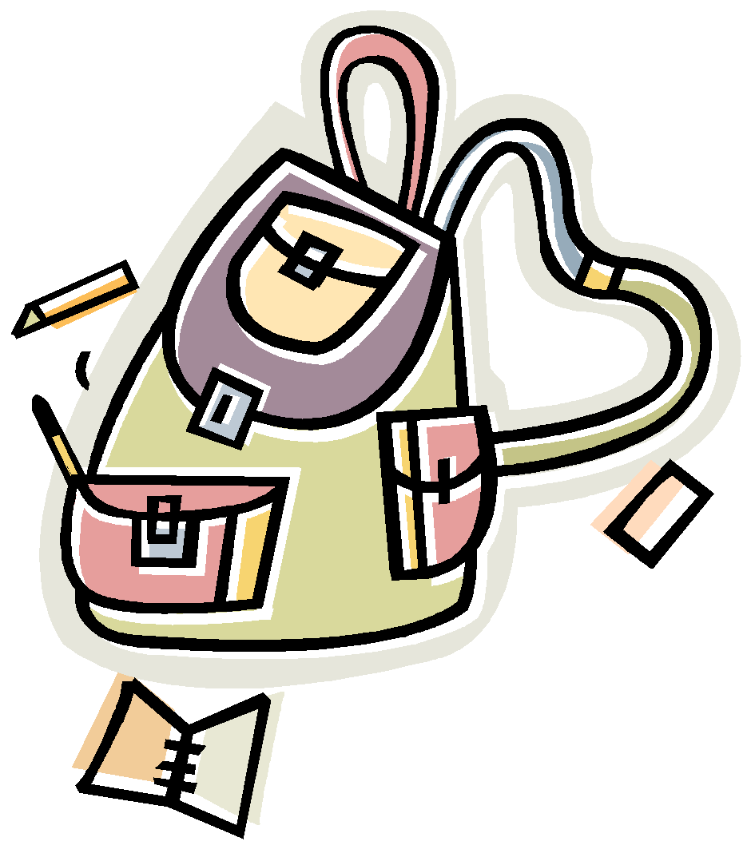
Arrangements for early closure for staff meetings, dates for tours, communion and confirmation practices in the church etc., will be conveyed by email.
It is important that parents ensure that the correct up to date phone number, email and postal address are made available to the school at all times.
Remember: ALWAYS CHECK THE SCHOOL BAG!

Cooking
This year all classes took part in various cooking classes. This was integrated with literacy, oral language and numeracy lessons as part of our literacy and numeracy strategy and SPHE lessons.

Digital School
Crinkill NS is innovative and proactive in the use of digital technology. We have been awarded the status of digital school of distinction by the Department of Education in recognition of this.

Drama
Drama is part of the weekly timetable in all classes. During term 2, Jared Madden, Professional Speech and Drama teacher works with all children in all classes with a view to staging our annual drama show at the end of the term - Parents are asked to contribute €2 weekly towards the cost, which includes tuition, costume, stage, lighting and sound system hire.

Early collection
Any child being collected before normal finishing time for appointments etc. are collected from the front reception by an adult who will be required to sign out the child. Please send in a written note with your child to their teacher, or an email to the office if they are being collected early.

Facilities
Each classroom in Crinkill National School has been built or renovated to a high standard with modern resources and facilities. In addition to its ICT resources, each classroom has a well-stocked library, wet area, ensuite toilets, art materials, games etc.

Gardening
The school has a number of raised beds which are used by groups of children from different classes to grow vegetables or flowers throughout the year.

Green schools
Crinkill National School is a Green school - this is an environmental project under the auspices of An Taisce - We have been awarded 5 Green Flags to date - litter reduction, energy conservation, water conservation, sustainable travel and biodiversity.

Head Lice
Occasionally, there can be incidents of head lice, especially in younger children - Please check your child's hair on a regular basis and in the unlikely event that you find evidence of head lice - this should not be the cause for embarrassment, please inform the school and treat repeatedly until the hair is clear.

Healthy Eating and Hot Lunches
There is a healthy eating policy in this school - please find a copy included in this pack. We appreciate parent’s co-operation in this regard. All children are provided with a hot lunch free of charge. Children should bring a snack and a drink from home for the first break. Parents order the lunch of their choice from our external supplier. Information will be provided separately on how to do this.

Homework
Generally, homework is assigned on a Monday - Thursday basis to reinforce learning - the content and quantity of homework is linked to the age of your child - please see full copy of Homework policy included in this pack. Please check that your child has completed the assigned each night.

ICT
All classrooms are equipped with interactive smartboards and laptops. We also have class sets of Samsung tablets - they are used to compliment teaching and learning in our school.

Illness
Please do not send your child to school if they have been unwell at home -this is in the best interests of your child and to help prevent spread of illness in the classes. If your child has been ill, please do not send them back into school until they are fully fit to return. Due to supervision issues, we cannot facilitate requests for children to stay inside at break time due to illness.

Illness during the school day
School will contact the parents or guardians. It is the responsibility of the parents to ensure that the school has up to date contact details and are contactable at all times.

In-school Management
Principal – Mrs Nolan
Deputy Principal – Ms O’Sullivan
Assistant Principal (I) – Ms Quigley
Assistant Principal (II) – Mrs Mannion
Assistant Principal (II) – Ms Kennedy
Assistant Principal (II) – Ms Lynch

Library
We work in conjunction with Birr Library throughout the year, taking part in various reading initiatives to promote an interest and joy of reading with our pupils.

Lunches
Each child attending Crinkill NS can avail of a free hot lunch for the second break of the day. Children should bring a snack and a drink from home for the first break. Parents will be given details of how to avail of this in September.

Medicine
It is the policy of the school not to involve teachers in administering medicine. If a child requires administration of medication during school hours, arrangements must be put in place - Please contact the school in this regard.

Mobile Phones
Children are not allowed to have mobile phones in school. All calls to parents are made from the office.

Music
Children take part in music/singing on a daily or weekly basis as part of their timetable with their class teacher. Older classes learn to play a musical instrument (at no additional cost to parents). Children in 1st class begin to learn the tin whistle. Ms Quigley is the school music co-ordinator and oversees the preparation of music for school masses, sacraments, the school choir and other events throughout the year.

Parents Association
Crinkill National School has an active and involved body of parents - All parents are automatically a member of the association once their child is enrolled in Crinkill NS -This is in line with the Education Act 1998 - The Parents Association AGM takes place annually (usually in the first term). All parents are invited to attend, and the working committee of the parents Association is elected at the AGM

Parent Teacher Meetings
Parent – Teacher meetings are held at the end of the first term (usually November). Parents are notified by a note in the school bag. A written report is issued at the end of the school year.

Parent-Teacher Communication
Parents are welcome and encouraged to discuss concerns or problems as soon as they arise.
In order to facilitate parent-teacher communications, parents are asked to make an appointment by phoning or calling to the office.

Parking
When parking at the school, we would ask all parents to be mindful of our neighbours and not park in gateways or block entrances. We would also remind parents not to park in the designated bus parking area or the staff parking area.

PE
All classes participate in PE on a weekly basis with their class teacher. Throughout the year, we have visiting professionals who work with the children in their relevant area of expertise. In the coming year the following is the proposed timetable for PE

Term 1 All classes – Hurling (GAA coach) – no fee to parents
All classes – Tag Rugby (Rugby coach) – no fee
Term 2 All classes - Hurling (GAA coach) - no fee
All classes – Dance (Lisa Hogan – Gravity Dance Academy) – no fee
All class – Tennis (Dermot Shiels – professional tennis coach) – no fee
Term 3 Older classes (4th – 6th) will participate in swimming (cost subsidised by school)
All classes - Athletics, games, orienteering - with Crinkill Sports & Recreation staff.
Active Schools Week - All classes - Daily events and end of week road race.
Annual Sports Day - All classes

Additional after-school training for sporting events/competitions - see after school events

School Books
Crinkill NS will be providing all schoolbooks free of charge to children in September. Parents will only be required to buy stationary/crayons etc.

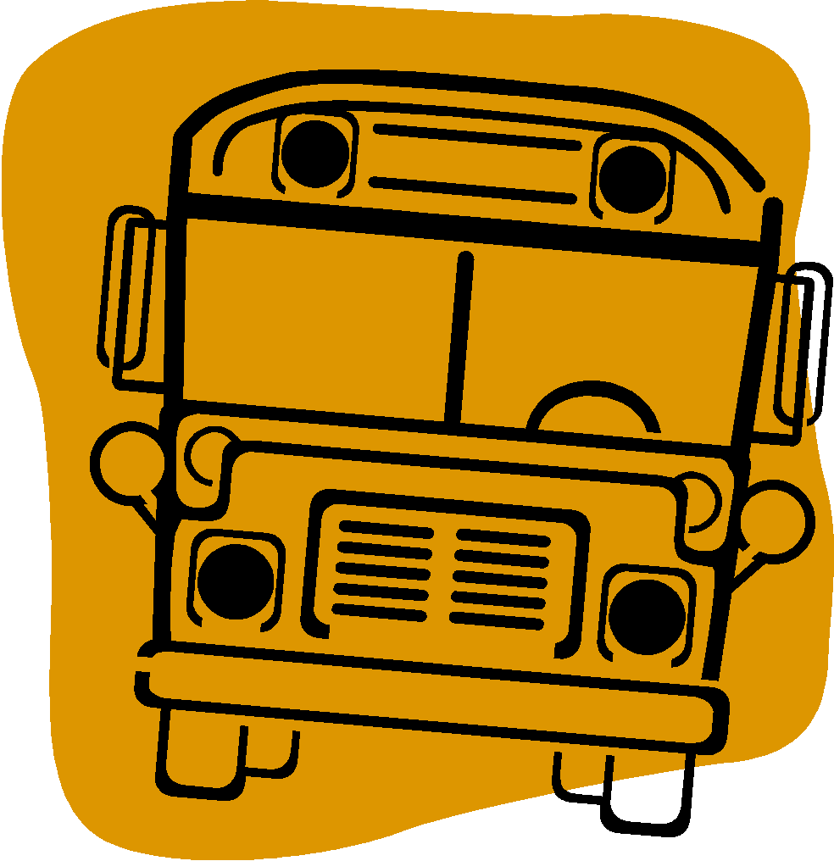
School Bus
The school bus service is provided by Bus Éireann. The Board of Management has no responsibility with regard to the school bus service. If parents have any concerns regarding this service, they should contact the service provider.

School Tour
Each class usually goes on an annual school tour in the last term as a reward for work done and good behaviour during the school year. The cost of the tour is usually subsidised through fundraising in order to make this as affordable as possible for parents - There are usually other small trips during the year to the theatre etc.

Social Media
The school has a presence on the following social media platforms:
Facebook.com/CrinkillNS
Instagram: @crinkillns
Twitter: @CrinkillNS
Please follow us, like and share our content, to keep up to date with events here in the school.

Uniform
Official Uniform is available from Declan Phelan Menswear, Connaught St, Birr
The official uniform for both boys and girls in Junior Infants is:
Green V-neck jumper with school crest (Hunter brand)
Light Blue Polo shirt (available in Declan Phelan’s, Dunnes, Tesco, M&S).
Plain Navy Shell tracksuit bottoms (no elastic at bottom of legs or logos/symbols).
Plain Runners/runner style shoes preferable Velcro closure without any lights.
1st to 6th class children are required to purchase the school formal uniform also (see uniform policy).

Visitors
All visitors including parents collecting or dropping off children during the school day must enter the school through reception - This is to comply with Health and Safety Guidelines. Entry to school playground by adults is not permitted.

After school
Infant children must be collected on time each day at 2pm. Older classes (1st -6th) finish at 3pm. Please collect your child from the front of the school where they will be dispersed individually by the class teacher. Parents wait outside the front wall. Please ensure that your child knows who is collecting them each day and if there is a change in arrangements, please notify the school.

After School Collection Service
Little Haven offers an after-school collection service. Contact: Ann Bergin - 086 0549000

